**Review Guide: Introduction to HTML and CSS**

Let’s review some of the key ideas introduced in this unit. You can also download all this content for future reference by clicking on the attached file.

**Key Definitions**

* **World Wide Web:** An information ­sharing model built on top of a global system of **inter**connected computer **net**works called the Internet.
* **Websites:** Collections of files, accessible through the world wide web.
* **Clients:** Personal devices such as computers, phones, or tablets, used to access the web.
* **Servers:** Special computers that host massive amounts of the files that make up websites. They “serve” those files to end users.
* **HTML Elements:** The building blocks of HTML. Consists of a start tag, content, and end tag.
* **HTML Tags**: HTML syntax used to indicate to a web browser how to present content. Bookended by angle brackets.

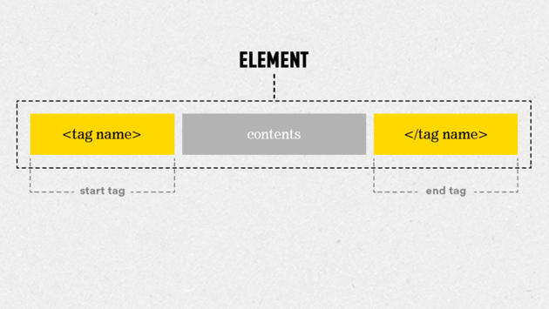

* **HTML Attribute:** Adds information to an HTML element. An HTML tag can have one or many attributes. Attributes are always included in the opening tag. They are preceded by a space, include the name of the attribute, an equal sign, and a value in quotes.

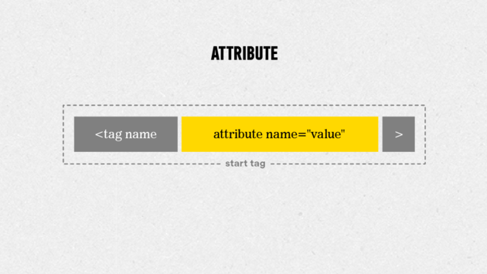

* **CSS Rule:** The building block of a CSS stylesheet. A rule consists of a selector and a declaration block (one or more declarations).
* **CSS Declaration:** A declaration is made up of a property name and a value, separated by a colon.
* **CSS Selector:** The actual HTML object the declaration(s) apply to.
* **CSS Property:** The characteristic of the selector that will be changed.
* **CSS Value:** The amount to change corresponding property of the matched selector.

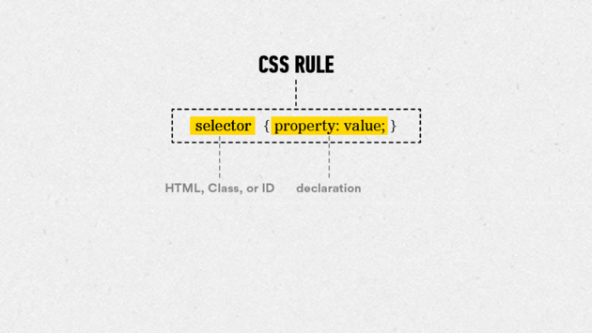

HTML vs. CSS

So what’s the difference between HTML and CSS? And when do I use each?

**HTML**, or **H**yper **T**ext **M**arkup **L**anguage, is the standard language used to code web pages. All of the content on a website is added with HTML.

**CSS** or **C**ascading **S**tyle **S**heets, decides how the content written in an HTML document looks, such as the layout, colors, and fonts.

**Common HTML Elements**

**Headline Elements:** are meant to be used for important text that titles the content that comes after it. They range from —the largest—to —the smallest.

<h1>This would make a big headline</h1>

**Paragraph Elements:** are one of the most basic tags in HTML. They indicate blocks of text.

<p>This would add a block of text to a page</p>

**Anchor Elements:** are the tags we use to create links. In order to make a working link, we have to add more information to the anchor tag, using an href attribute.

<a href="www.generalassemb.ly>This would make this whole

sentence a link to General Assembly's home page.</a>

**HTML Boilerplate**

In order to organize tags properly, start with a set of structural elements called the HTML boilerplate. It should look like this:

***<!DOCTYPE html>***

<html>

<head>

</head>

<body>

</body>

</html>

**Common CSS Properties and Values**

**Property #1:**  
**color —** This CSS property allows you to adjust the *text* color of the selected element.

For example, to turn the text of an element green, you would create the following CSS rule:

h1 {

**color:** #00ff00;

}

**Property #2:**  
**background-color —** This CSS property allows you to adjust the *background* color of the selected element.

For example, to turn the background of a web page yellow, you would enter the following CSS rule:

body {

background**-color:** #ffff00;

}

**Common Values:**  
There are 17 standard color values that you can pair with the color and background-color properties — aqua, black, blue, fuchsia, gray, green, lime, maroon, navy, olive, orange, purple, red, silver, teal, white, and yellow.

Additionally, there are 123 more colors that are generally accepted as standard. You can find the entire list [here](http://www.w3schools.com/cssref/css_colornames.asp).

You can also create custom colors using RGB and hexadecimal codes, which we'll discuss in Unit 3.

**Questions to Ask Your Mentor**

1. How did you first get introduced to HTML and CSS?
2. Can you show me some examples of websites with basic HTML and CSS code?
3. What are your favorite web designers and websites?
4. Before you sit down to create a website, what steps do you take to prepare?
5. What are some good resources that you typically use for learning about web design?

**Resources**

* [Sublime Text](http://www.sublimetext.com/3) — A free text editor used for building HTML and CSS files. It's available for both Mac OS X and Windows.
* [Google Chrome](https://www.google.com/chrome/browser/desktop/index.html) — The primary web browser used to demonstrate rendered code throughout this course. It's available for both Mac OS X and Windows.
* [wireframe.cc](https://www.wireframe.cc/) — A free tool for creating web design mockups. It operates in your web browser, so you don't even need to download it. You'll learn how to create design mockups with wireframe.cc in our next unit.

**Further Reading**

Looking for more help with the Basics of HTML? Here are a couple places you can check out:

More basics on HTML and CSS (read up until the section called "In Practice"):  
<http://learn.shayhowe.com/html-css/terminology-syntax-intro>

More info on getting started:  
[http://www.htmldog.com/guides/html/beginner/gettingstarted](http://www.htmldog.com/guides/html/beginner/gettingstarted/)

Intro to HTML tags:  
<http://www.htmldog.com/guides/html/beginner/tags/>

Intro to title elements:  
<http://www.htmldog.com/guides/html/beginner/titles/>

Intro to paragraph elements:  
<http://www.htmldog.com/guides/html/beginner/paragraphs/>

Intro to heading elements:  
<http://www.htmldog.com/guides/html/beginner/headings/>

The first web page ever posted on the Web:  
<http://info.cern.ch/hypertext/WWW/TheProject.html>

Also, please feel free to reach out to your mentor to discuss any of the topics in this unit further.

[←](https://circuits.generalassemb.ly/student/209/pages/785?direction=back) [→](https://circuits.generalassemb.ly/student/209/quizzes/232)

**Downloads**

[Summary](https://ga-sprites.s3.amazonaws.com/uploads/production/page/downloadable_content/137/Summary.zip)

© 2016 General Assembly. All rights reserved. [Regulatory Information](https://generalassemb.ly/regulatory-information) [Terms](https://generalassemb.ly/terms_and_conditions) [Privacy](https://generalassemb.ly/privacy_policy) [Assembled](http://nytm.org/made-in-nyc)

# Project: Part 1 — Creating Your First Web Page

Welcome to your first Circuits project!

Throughout the course, we’ll guide you through the creation of your very own website. The content of your website will revolve around a business. It can be a real business that you own or work at, a fictional business that you'd like to create, or a personal brand page.

If you’re interested in seeing some previous students' final projects to get some inspiration, you can do so [here](https://gallery.generalassemb.ly/WDC?metro=).

In this week's project, you'll create a basic web page and host it online. The following steps will help guide you:

## Step 1

Create a new folder on your computer.

To create a new folder, go to the location where you want to create a new folder (such as your documents folder or the desktop) and right-click any blank area (or press CTRL + click). This will create a pop-up menu from which you can select **new folder**.

Name your new folder **unit_1**.

## Step 2

Open Sublime Text and create a new file. Name the file **index.html** and save it in the **unit_1** folder you created in Step 1. This will tell Sublime Text that the file you're working on is an HTML file.

## Step 3

Incorporate the HTML boilerplate elements into your index.html file:

<!DOCTYPE html>

<html>

<head>

<title>

<body>

The title for this webpage should be: “[the name of your business]”

## Step 4

Populate the body element with the <h1> text: “[the name of your business]” and the paragraph text: “This is the [business type] of [your name here]”

For example:

<body>

<h1>Batcave</h1>

<p>This is the secret headquarters of Batman</p>

</body>

You probably have a lot more to say than that, but don't worry! You'll have plenty of time to upgrade the text on your site later. Our main focus for now is getting your page up and running.

## Step 5

Within your **unit_1** folder, create a subfolder called **css**.

Back in Sublime Text, create a new file, name it **style.css**, and save it in your new **css** folder. This will be your external style sheet.

In this file, set the text color to any color besides black, and the background color to any color besides white.

For example:

body {

background-color: black;

}

h1, p {

color: gold;

}

When you're done, make sure to link to your new style sheet to your web page inside the <head> section of your HTML file using the following element:

<link rel="stylesheet" type="text/css" href="css/style.css">

Don't forget to save **both** your HTML and CSS files once you've reached this point.

## Step 6

Congrats! You've created the files necessary to create a basic web page. Next, you're going to take these files and host them online using a service called GitHub.

To learn how, please continue to the next activity, which is a step-by-step slideshow to help you through this process.

[←](https://circuits.generalassemb.ly/student/209/quizzes/232?direction=back) [→](https://circuits.generalassemb.ly/student/209/slideshows/198)

© 2016 General Assembly. All rights reserved

text-align: center;

text-decoration: none;

text-transform: uppercase;

background: #000

color: #fff

font-family: Arial, sans-serif;

size:24px;

font-style: normal;

font-weight: bold;

**Review Guide: Principles of HTML & CSS**

Let’s review some of the key ideas introduced in this unit. You can also download all this content for future reference by clicking on the attached file.

**Key Definitions**

* **Rule**: The building block of a CSS stylesheet. A rule consists of a selector and a declaration block (one or more declarations).
* **Declaration**: A declaration is made up of a property and a value, separated by a colon and punctuated by a semi-colon."
* **Selector**: The actual HTML object the declaration(s) apply to.
* **Property**: The characteristic of the selector that will be changed.
* **Value**: The amount or type of change to be applied to the corresponding property of the matched selector.

  
- **Marking-Up**: The process of assigning HTML tags to given text content in order to indicate its relation to the rest of the text or dictate how it should be displayed.  
- **Serif Font**: One of two general categories of fonts (typefaces) that uses marks (called “serifs”) to embellish characters. A common serif font is “Times New Roman”.  
- **Sans-Serif Font**: One of two general categories of fonts that have cleaner line due to not using marks to embellish characters. (Sans Serif literally meaning “Without serif”) A common sans-serif font is “Helvetica”.  
- **Class**: A class attribute is added to an HTML element in order to give you a “hook” to refer to that element in your CSS. CSS class selectors begin with a “.”. Classes can be used multiple times per page.  
- **ID**: An id attribute is added to an HTML element in order to give you a “hook” to refer to that element in your CSS. CSS id selectors begin with a “#”. IDs can only be used one time per page.  
- **Horizontal Rule:** Add a horizontal line across your page using the hr tag.  
- **Line Break:** Break up a block of text using the br tag.  
- **Image:** Add images to your HTML using the img tag. Tell the browser the source of the image file with an src attribute.  
- **Absolute File Path**: A path to a website or file that includes a full web address (starting with “http”) that the browser loads from the remote location directly. For example:

**<**img src**=**"http://imgur.com/awesomedog.jpg"**>**

* **Relative File Path**: A path to a website or file that gives you the path to the resource you are looking for as it relates to your website's local file structure. For example, if you wanted to retrieve an image called *newlogo.png* that resides in a file called *img*, you would enter the following relative address:

**<**img src**=**"images/awesomedog.jpg"**>**

**Why Separate HTML from CSS?**

Separating HTML from CSS offers you scalability and versatility. If you separate how your site looks from what your site says, things become more flexible.

By separating your HTML and CSS, you can make the change in one place and have it apply to your whole site. If you separate what your site says from how it looks, you can apply any number of different styles to the same content.

**CSS Color Treatment**

While color names are fine when you're just beginning, there's a number of reasons you'll want to switch over to something more advanced.

First, color names are rendered differently by different browsers. Secondly, there are only 147 color names accepted as standard, meaning your options are going to be pretty limited.

Instead, you'll want to use either RGB or hexadecimal codes. Both of these are built on a system of entering values for the colors red, green, and blue.

By mixing different intensities of these three colors, you can create millions of different colors and shades. Intensity values range from 0 (no intensity) to 255 (full intensity) in the RGB system.

In hex, they range from 0-9, then continue from A-F, with two characters each for red, green, and blue.   
This is clearer with examples, so [here are some common colors with their RGB and Hex equivalents](http://www.w3schools.com/tags/refcolortryit.asp?color=White).

The format for color names, RGB, and hexadecimal should look like the following, respectively:

p {

**color:** red;

}

p {

**color:** (255,0,0);

}

p {

**color:** #FF0000;

}

**CSS Text Treatment**

* **font-family**

To adjust the font of your selected text element, use the font-family property. For the value, enter the name of the font to which you’d like to alter your text.

To be safe, try putting a comma after your selected font and enter a generic family as a fallback. If the web browser doesn’t support the font you selected, it will choose the fallback.

h1 {

font**-family:** Arial, sans**-**serif;

}

If your selected font is more than one word, capitalize both words and put them in quotation marks.

h1 {

font**-family:** "Courier New", monospace;

}

* **font-size**

To increase or decrease the spacial dimensions of your chosen text, use the font-size property. As a beginner, you’ll want to enter pixel values for your font-size values.

h3 {

font**-size:** 24px;

}

As you become more advanced, try using percentages or ems instead of pixels. These can be pretty tricky, though, so you may want to wait until we cover them in Unit 9.

* **font-weight**

To adjust the thickness of your selected text, use the font-weight property.

As a beginner, you can enter values like “normal” to make your text thin and “bold” to make your text thick. As these values aren’t very specific, different browsers may interpret their display with slightly different outputs.

h1 {

font**-weight:** normal;

}

h1 {

font**-weight:** bold;

}

As you become more advanced, try using the numbers 100, 200, 300, 400, 500, 600, 700, 800, and 900 as values to gain more granular control. With this system, 400 is roughly equivalent to “normal” and 700 roughly equals “bold.”

h1 {

font**-weight:** 400;

}

h1 {

font**-weight:** 700;

}

* **font-style**

To make normal text italic, use the property font-style and the value “italic.” To reverse this effect, use the value “normal.”

a {

font**-style:** italic;

}

a {

font**-style:** normal;

}

* **text-align**

To adjust the positioning of a text element, use the CSS property text-align and one of the following values: left, right, center, or justify.

body {

text**-align:** center;

}

* **text-decoration**

To add an underline to normal text, use the CSS property text-decoration and the value “underline.”

h1 {

text**-decoration:** underline;

}

To remove underlines, use the value “none.” This declaration is often applied to anchor tags.

a {

text**-decoration:** none;

}

Less commonly used values include “overline” to add a line above text and “line-through” which strikes a line through your text.

* **text-transform**

To adjust capitalization in a selected text element, use the text-transform property.

Values for this property include “uppercase” to make every letter capitalized, “lowercase” to make every letter uncapitalized, and “capitalize” to make the first letter of every word in the selected text uppercase.

h1 {

text**-transform:** uppercase;

}

**Sublime Text Shortcuts**

* **Quick Save:** ⌘+S (for Mac) or CTRL+S (PC)
* **Instant Boilerplate:** Type “html” + TAB (Mac and PC)
* **Instant Lorem Ipsum:** Type “Lorem” + TAB (Mac and PC)
* **Add Comment:** ⌘+/ (for Mac) or CTRL+/ (for PC)
* **Undo:** ⌘+Z (for Mac) or CTRL+Z (for PC)
* **Redo:** ⌘+Y (for Mac) or CTRL+Y (for PC)

**Classes vs. IDs**

Classes and IDs, also called selectors, are ways of targeting the style of specific HTML elements on your page.

So what’s the difference between them?

In short, classes allow you to style many elements with a particular style, while IDs are only capable of styling a single element.

Using these selectors allows you flexibility and control of styling individual, as well as groups, of elements on your page.

**HTML and Images**

When you’d like to add images to your site, you should use the tag with the “src” attribute. “src” stands for “Source” and works just like the tag’s “href” attribute. It tells the image tag where to find the image you’d want to include on your page.

**Relative vs. Absolute Addressing**

Relative addressing basically tells your browser: “Look in our project folder for the file specified. Or, if a folder is specified, look within that folder for the file specified.”

On the other hand, when we link to a source outside of our project, it is referred to as an absolute address.

**Sublime Text Shortcuts**

Bookmark [this guide](https://docs.google.com/document/d/1LugbQxfLpG5yFNfTz22hnGclN1Fwp_PH5QZfk0KLjO0/edit?usp=sharing) or download it for review.

**Questions to Ask Your Mentor**

1. Why is it important to create separate HTML and CSS documents? Can you explain separation of concerns in greater detail?
2. How do I get started with creating an external style sheet? What elements should I define the style for first?
3. Where can I find examples of external style sheets to use as templates?
4. What are some best practices for organizing my files and folders on my computer? Should I be saving my work elsewhere?
5. Which fonts should I use for my project?

**Further Reading**

How the RGB Color System Works  
<http://en.wikipedia.org/wiki/RGB_color_model>  
<http://www.rgbworld.com/color.html>

More on Colors  
<http://www.w3schools.com/cssref/css_colornames.asp>  
<http://www.color-hex.com/>

Adobe Color CC (formerly known as Adobe Kuler)  
<https://color.adobe.com/create/color-wheel/>

More on Fonts   
<http://www.w3schools.com/css/css_font.asp>  
<http://www.w3schools.com/cssref/css_websafe_fonts.asp>

Difference Between Serif and Sans-Serif   
<http://www.urbanfonts.com/blog/2013/02/serif-vs-sans-the-final-battle>

Classes and IDs   
<http://css-tricks.com/the-difference-between-id-and-class/>

File Paths   
<http://css-tricks.com/quick-reminder-about-file-paths/>

Absolute vs. Relative Paths  
<http://www.coffeecup.com/help/articles/absolute-vs-relative-pathslinks>  
<http://www.boogiejack.com/server_paths.html>

# Building Your Home Page

In this unit, you learned how to expand your color palette by a couple million values, how to style text and font, how to label and manipulate elements with classes and IDs, how to add images, and more! Did you also know semantic HTML is a vital step in defining your content? If not, don’t worry! The Unit 3 lecture will tell you all about it.

In this project, we’ll revisit the page you made in Unit 1, and we’ll give it a few upgrades.

Let's get started!

## Step 1:

If you haven’t already created a **unit_3** subfolder in your local GitHub folder, do so now. Within that folder, create two subfolders. Name one subfolder **images** and the other **css**.

Then, create a new file in Sublime Text and save it in this folder as **index.html**. Don’t worry that it has the same filename as the Unit 1 project. It’s okay to have multiple files in your GitHub folder named index.html as long as they’re not in the same unit subfolder. Your homepage should always be named index.html.

Next, recreate the HTML you had in your Unit 1 project. If you want to save time, feel free to copy and paste your original code. If you’d like some extra practice, you should recreate it from scratch.

If you start from scratch, try using the time-saving Sublime Text technique we showed you to create your HTML boilerplate (after saving the file as a .html file, type **html** and hit the **tab** key).

At this point, your HTML should contain at least the following:  
- The HTML boilerplate  
- A title your page "[Your business name]"  
- An <h1> with your business name  
- A <p> tag with a little information about your business

Okay, now that we’re all on the same page, let’s get building!

## Step 2:

First, let’s update the copy in your <p> element. Instead of just a description of your business, let’s make it a slogan! In fact, let’s give it the ID “slogan.” Try to come up with a fun, catchy phrase that captures the spirit of your business. If you’re short of ideas, try using one of the following slogan generators: <http://slogangenerator.co/> or <http://www.sloganizer.net/en/>

Beneath your slogan, add a hero image. This should be a large image that sets the tone of your site. For example, if your business is a restaurant, add a photo of something delicious. If it’s a personal blog, maybe add a photo of yourself or an image representative of the topics about which you’ll write.

Remember, there are two ways to add an image:

Option 1 (best practice) — Host your image locally by putting it in the **images** subfolder inside your ** unit_3** folder, and use a ** relative file path** to reference the image.

Option 2 — Find an image online. Right click on the image (or press **CTRL** + ** Click** ) and select “Copy Image URL.” Then, use an ** absolute file path** to reference the image.

A common technique for slightly more advanced users is to add an image using the ** background** property in CSS. This will allow you to have text on top of the image. Try this out if you’re feeling ambitious!

Underneath this new image, create another paragraph with a few sentences telling us about your business. Maybe talk about your history or your mission. Beneath this paragraph, add an unordered list that summarizes a few of your business’s offerings.

Finally, at the bottom of your HTML, add the phrase “Contact me:” with your email address following. Turn your email address into a link. To go above and beyond, see if you can make your email link automatically open an email that’s addressed to you. It’s easier than you think!

## Step 3: Make it Personal

The above content is primarily educational — we want to make sure you can apply the lessons in this unit; however, we understand that you probably have some cool content ideas of your own, so please take this step to add any additional content to your site that you’d like.

The more content you add now, the more interesting style and layout opportunities you'll have later. If you don't have ideas, check out competitor pages and see what content they include on their home page and how it's organized.

Also, add a line or two of space between chunks of content that you imagine will eventually be broken into different sections (as per your design mockup). Don't worry, those lines of space won't affect the layout of your content when it's rendered on the screen. The purpose for such space is simply to make your code more legible and to facilitate future organization of your code.

Additionally, we won’t be adjusting layouts until Unit 6; however, to make the layout process easier, for the time being, list your content as you expect it to eventually appear, top to bottom, left to right.

Once you’re finished adding content, save it. Now, it’s time to style your HTML.

## Step 4: Styling Your Content with CSS

Create a new file in Sublime Text and save it as style.css in the css subfolder of your unit_3 folder. Make sure to add a link to your CSS in the section of your HTML. Save your HTML again once you’ve added it, then return to your stylesheet.

Consider the selectors you have available:

body

h1

p

ul

li

img

#slogan

Now, let’s give these elements some style! First, give your page’s <body> and <h1> elements unique colors using either the RGB or hexadecimal methods. If you’re having trouble picking the proper hues, check out a site like [Adobe Color CC](https://color.adobe.com/create/color-wheel/?base=2&rule=Custom&selected=4&name=My%20Color%20Theme&mode=rgb&rgbvalues=1,0.13279019591095675,0,0.5,0,0,1,0,0,1,0,0,1,0,0.37792984243083083&swatchOrder=0,1,2,3,4).

Next, make your slogan italicized.

After that, it’s up to you! Play around with the CSS properties you’ve learned thus far and adjust your site however you see fit.

background

background-color

color

font-size

font-style

font-weight

text-align

text-decoration

text-transform

## Step 5: Review the checklist below to make sure your project is ready to submit.

1. I’ve added all content to my page, even if it doesn’t look like my unit 2 sketch
2. I’ve used semantic tags correctly (I learned in the lecture!)
3. I’m using the simple reset (I learned in the lecture!)
4. I made sure to include alt attributes on all of my image tags
5. I only used classes and id's when absolutely necessary

**Thought this unit was the most challenging so far? It was!**  
Book a 1:1 with your mentor by clicking My Mentors.

## Step 6: Host your project for submission

Make sure you’ve saved your finished HTML and CSS files. Then, commit and sync your changes using the GitHub app. The link for your site should be:

<http://your_repository_name.github.io/unit_3/index.html>

If that doesn’t work, go to github.com, open your repository, and copy and paste the URL. Then, discuss whatever issues you had with your mentor.

## Advanced Study:

Try taking your page to the next level with some new CSS properties affecting layout. We're not covering these properties until a later unit, but try doing some quick research and see if you can figure them out!

margin

padding

border

width

text-align

NOTE: If you try to center your list with text-align: center, you'll notice that the list-items and their bullets behave in different ways. There's a reason for that, but it's not one you need to worry about yet.

A good workaround for right now—and one you'll find super-helpful very frequently—is to make the bullets invisible by including the following CSS rule in your stylesheet:

ul {

text-align: center;

list-style-type: none;

}

* [9 of 11 Review Guide: Web Design Basics](https://circuits.generalassemb.ly/student/209/pages/806) 
  + [Video: Typography Fundamentals](https://circuits.generalassemb.ly/student/209/pages/801)
  + [Video: Typography and Readability](https://circuits.generalassemb.ly/student/209/pages/802)
  + [Code Challenge: Line Height](https://circuits.generalassemb.ly/student/209/code_challenge/challenges/144)
  + [Video: Typographic Pairings: Best Practices](https://circuits.generalassemb.ly/student/209/pages/803)
  + [Code Challenge: Fonts](https://circuits.generalassemb.ly/student/209/code_challenge/challenges/145)
  + [Video: Advanced Typographic Considerations](https://circuits.generalassemb.ly/student/209/pages/804)
  + [Code Challenge: Using Web Fonts](https://circuits.generalassemb.ly/student/209/code_challenge/challenges/146)
  + [Video: Color — Typography and Beyond](https://circuits.generalassemb.ly/student/209/pages/805)
  + [Review Guide: Web Design Basics](https://circuits.generalassemb.ly/student/209/pages/806)
  + [Quiz: Web Design Basics](https://circuits.generalassemb.ly/student/209/quizzes/235)
  + [Set the Font to Set the Tone](https://circuits.generalassemb.ly/student/209/assignments/158)
* [My Mentors](https://circuits.generalassemb.ly/student/209/mentors)
* [Lectures](https://circuits.generalassemb.ly/student/209/lectures)
  + [My Profile](https://circuits.generalassemb.ly/me)
  + [Edit my Profile](https://circuits.generalassemb.ly/me/edit)
  + [My Account](https://accounts.generalassemb.ly/account)
  + [Sign Out](https://circuits.generalassemb.ly/sign_out)
* [HTML, CSS & Web Design Circuit](https://circuits.generalassemb.ly/)
* [My Mentors](https://circuits.generalassemb.ly/student/209/mentors)
* [Lectures](https://circuits.generalassemb.ly/student/209/lectures)
* [My Profile](https://circuits.generalassemb.ly/me)
* [Edit my Profile](https://circuits.generalassemb.ly/me/edit)
* [My Account](https://accounts.generalassemb.ly/account)
* [Sign Out](https://circuits.generalassemb.ly/sign_out)

# Review Guide: Web Design Basics

Let’s review some of the key ideas introduced in this unit. You can also download all this content for future reference by clicking on the attached file.

## Key Definitions

* **Glyph**: A single symbol of a given typeface. Individual letters, numbers, and punctuation are the most commonly used glyphs.
* **Typeface**: An entire family of glyphs defined by shared visual characteristics, e.g., Helvetica.
* **Font**: A specific set of characters of a given typeface, e.g., 12pt Helvetica Bold.
* **Serif**: A bracket-like extension from a stroke of a glyph that is usually not part of its essential structure. Common serif typefaces used in web design: Hoefler Text, Garamond, Times New Roman, and Perpetua.
* **Sans Serif**: Typefaces lacking serifs. Colloquially shortened to _sans—_French for “without.” Common sans serif typefaces used in web design: Helvetica, Futura, Gill Sans, and Arial.
* **Point**: Common size measure of a typeface from the apex of the tallest ascender, e.g., the top of a lowercase “f,” to the base of the longest descender, e.g., the lowest point of a lowercase “y.”
* **Font Stack**: A prioritized listing of typefaces based upon a shared classification, as a means to standardize viewing experiences across browsers.
* **X-height**: The measure from the top of the lowercase “x” of a given typeface to the baseline, the optical plane on which a line of type rests.
* **Baseline**: The optical plane on which a line of type rests.
* **Cap Height**: The height of a capital letter above the baseline.
* **Header**: Often referred to as headlines and subheads. These are usually a focal point on a page and are visually reinforced by size and whitespace. In HTML, features of this type are normally created with the h1 through h6 elements.
* **Body**: Also referred to as “body copy” and not to be confused with the HTML body element, this term refers to visually smaller, long-form paragraph text. In HTML, features of this type are normally created with the p element.
* **Line Length**: Frequently measured in the number of characters per line.
* **W3C**: An international consortium focused on developing web standards.
* **Type Foundry**: A business that builds and sells typefaces.
* **EM (CSS)**: The value of this element ties an element’s size relative to a default value.
* **Ligatures**: Common glyph pairs joined as a single unit.
* **Alternates**: Additional versions of standard characters such as swashes.
* **Small Caps**: Capitals designed specifically to pair with lowercase letters.
* **Rivers**: An excess of vertical negative space that runs through blocks of copy and interferes with readability.
* **En Dash**: Used to indicate a range of values, e.g., “3–4 times per week.”
* **Em Dash**: Used to indicate a break in thought, e.g., “if you have questions regarding grammatical style—and the corresponding typographic design conventions—a resource will be provided.”
* **Smart Quotes**: AKA typographer’s quotes. These are used for apostrophes and quotation marks. Smart quotes look like this: (“ ”).
* **Prime Marks**: Used for measurement: (' ").

## Web-Based Type: Readability And Legibility

Legibility and readability of type are two factors that mediate text-based communication.

* **Legibility**: the degree to which the details of a typeface can be discerned, rooted in the physical characteristics of the typeface itself. Poor legibility example: small, heavily bitmapped text.
* **Readability**: the degree to which text can be read and ultimately understood, a function of the arrangement of text. Poor readability example: a paragraph of otherwise legible text set with too little space between lines.

## Typographic Pairings

Let’s review a few key ideas around pairing typefaces:

**I. Typeface selection is largely based upon its function.**

* Outline the text-based needs of the page and, ultimately, the site.
* Select your typefaces accordingly.

**II. Initial selection of family pairs frequently begins with one sans and one serif.**

* This will give the designer/coder a high degree of contrast between type—contrast between these classifications is generally greater than between two sans or two serif faces.

**III. Select typefaces with ample degrees of weight.**

* Common practice dictates leaving at least one degree between weights of a typeface when creating visual contrast.

## Typographic Sins and Virtues

**Use only a single space following periods or any other punctuation at the end of a sentence.**

The usage of a double space between sentences is a relic of the days when typewriter usage was the norm. More importantly, usage of the double space throughout a page creates “rivers,” an excess of vertical negative space that runs through blocks of copy and interferes with readability.

**Understand the functional and physical differences between hyphens (-), en dashes (–), and em dashes (—).**

An intro to rules of usage: hyphens join compound words, e.g., “a blue-green sea;” en-dashes are used to indicate a range of values, e.g., “3–4 times per week;” and em dashes indicate a break in thought, e.g., “if you have questions regarding grammatical style—and the corresponding typographic design conventions—a resource will be provided.”

**Use typographer’s quotes (“ ”), also know as “smart quotes” for apostrophes and quotation marks; use prime marks (") for measurement.**

Typographer’s quotes — Matthew Carter remarked, “type is a beautiful group of letters, not a group of beautiful letters.”

Prime marks — Stefan Sagmeister, the Johnny Depp of the design world, is 6*'5"* tall.

## Typography and Color

The use of color on the web can create, entice, or repel users. It can establish a focal point or create distraction, and it can assist in way-finding or add confusion for the user.

**Color and Navigation**:  
Color is often applied to text as a significant navigational aid. For example, moving the pointer over navigational text can trigger a “hover state,” changing the appearance of text and providing a cue to the user.

**Color Selection — Emotional:**  
Color is used to evoke an emotional response by drawing upon familiar associations. For example, red hues are evocative of energetic states and can imply activity. Blue hues, the color of the skies and oceans, can inspire feelings of serenity and security.

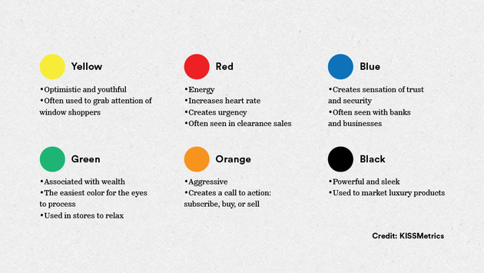  
**Color Selection — Technical**:  
Analogous Colors: Colors that are adjacent along the color wheel, e.g., green, yellow, and orange.

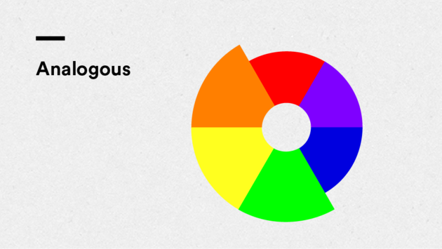  
Complementary Colors: Colors that are opposite one another on the color wheel, e.g., blue and orange.

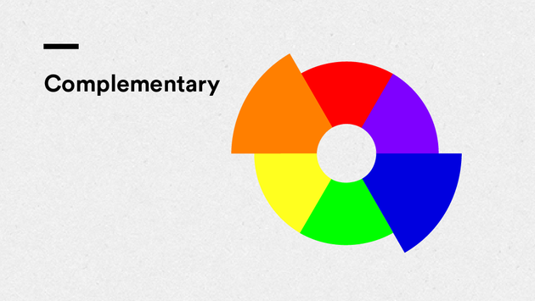  
Triadic Colors: Colors that are equally spaced apart along the color wheel. The primary colors—red, blue, and yellow—are an example of triadic colors.

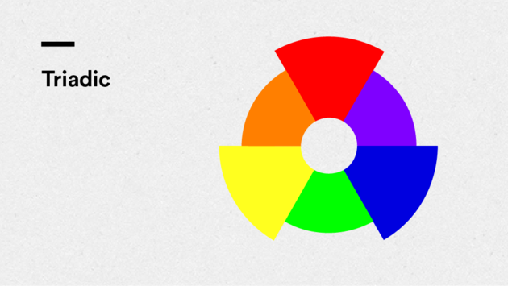  
Monochromatic Colors: A color scheme built upon a single hue, i.e., tints and shades of one color.

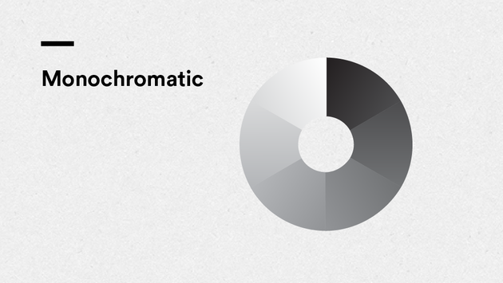  
**Color Models — RGB vs. Hex:**  
RGB: A model that expresses the additive color process as values of red, green, and blue ranging from 0 to 255.

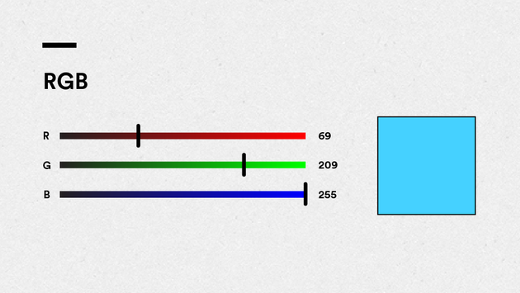  
HEX: Color on the web, represented by its hexadecimal value..

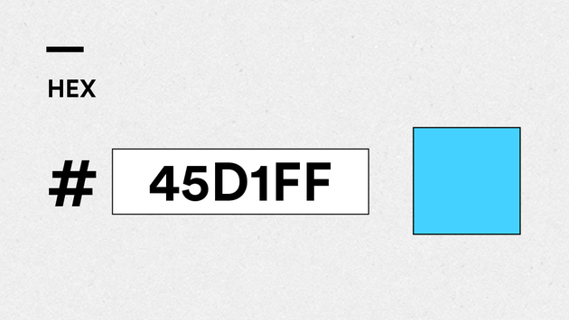

## Questions to Review With Your Mentor

What do I need to know in order to become conversant with the basics of typography?

Where can I find inspirational sites that effectively use color?

What are good resources I can reference for additional readability and accessibility insights?

Are there standard typographic conventions I should adhere to?

What are the color models that are most relevant to the web designer/coder?

## Further Reading

Looking for more help with typography and color? Here are a few places you can check out:

A further discussion of typographic basics can found at FontShop, a highly-regarded type design company:  
<http://www.fontshop.com/education/>

Strong typographical resource site:  
<http://ilovetypography.com/2008/03/21/extreme-type-terminology/>

Articles such as How People Read on the Web: The Eyetracking Evidence demonstrate the importance of readability, layout, and hierarchy in web design:  
<http://www.nngroup.com/reports/how-people-read-web-eyetracking-evidence/>

Hoefler & Co. is a highly regarded type foundry, a company that designs and distributes typefaces, and offers a Combing Fonts page on their site that is both informative and visually inspiring:  
<http://www.typography.com/techniques/index.php>

For more on advanced typesetting concepts see Type on Screen: A Critical Guide for Designers, Writers, Developers, and Students by Ellen Lupton, a designer and educator well known for her writings on typography and design:  
<http://www.papress.com/html/book.details.page.tpl?isbn=9781616891701>

Strunk and White’s The Elements of Style is an English writing and style reference frequently referred to by writers, readers, and designers alike:  
[http://www.amazon.com/Elements-Style-Illustrated-William-Strunk/dp/0143112724/ref=sr11?s=books&ie=UTF8&qid=1296660224&sr=1-1](http://www.amazon.com/Elements-Style-Illustrated-William-Strunk/dp/0143112724/ref=sr11?s=books&amp;ie=UTF8&amp;qid=1296660224&amp;sr=1-1)

Companies such as the Color Marketing Group monitor trends and forecast colors:  
[http://www.colormarketing.org](http://www.colormarketing.org/)

Maintain your awareness of current design trends and bolster your technological prowess by continuously learning through sites such as A List Apart and Communication Arts:

* [http://alistapart.com/topic/typography-web-fonts](http://alistapart.com/topic/typography-web-fontshttp:/alistapart.com/topic/typography-web-fonts)
* [http://www.commarts.com](http://www.commarts.com/)

# Set the Font to Set the Tone

Web Fonts might seem easy, but type design can make a huge impact on your design. Check out the lecture this week to learn ways to make your site look even better.

For your Unit 4 project, we’re going to take your business website to the next level by upgrading the typography.

## Step 1: Setup

Pull up your HTML and CSS from the Unit 3 Project. In this unit you're going to set the fonts for your webpage. This is done in the CSS by using the property "font-family" on the selectors you wish to adjust.

While there are a number of fonts that are automatically recognized by browsers — classics like Times New Roman and Arial — we’re going to make it more interesting by adding fonts from the web using Google Fonts.

**Note:** If you have multiple <p> elements or headlines and you want to give them different fonts, remember to use a class or ID to give yourself more granular control.

## Step 2: Exploring Google Fonts

Once you’ve chosen two elements you’d like to give new fonts, go to [www.google.com/fonts](http://www.google.com/fonts) and think about what kind of typography will best communicate your business's identity to your target customers.

Use the search bar or the filters in the left-hand column to narrow down fonts by type; consider weight, width, and other typographic elements covered in this unit. Do you want text that’s sleek? fun? old-fashioned? futuristic? For practice, try experimenting with a few different typefaces on your page.

Generally speaking, you should be looking for one typeface that is for the majority of your text and one typeface that is for your headers. These can be either be two different font-families or it can be two different styles of the same typeface. The important thing to remember is that your base font styles (paragraphs, list items, links, etc) must be a font that is easy to read for the best user experience.

After you find a typeface that you like, click on the button surrounded the red box below:

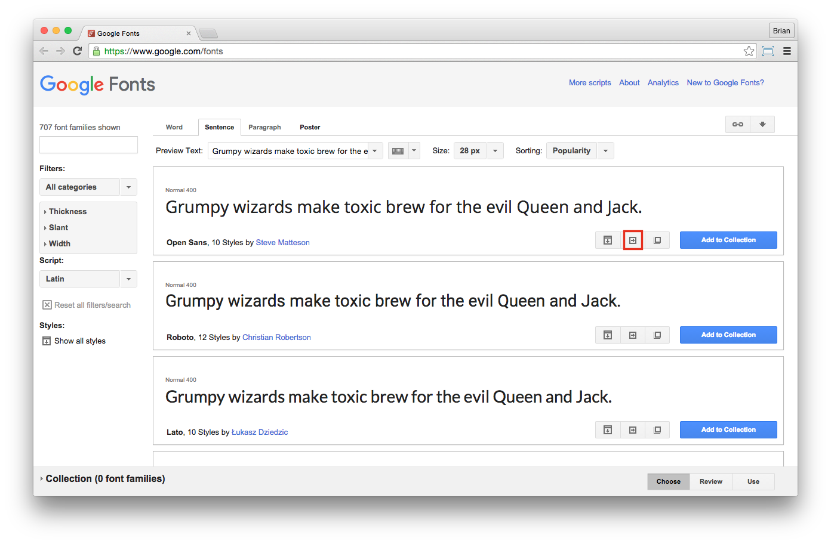

## Step 3: Adding Google Fonts

That button will take you to a new page with more information about the typeface you selected. Sections 1 and 2 on this page allow you to fine tune your selection.

To add this new typeface to your website, scroll down the page to section 3 (blue box in the image below), click on the tab that says **@import**, and copy the code in the box to the very top of your external style sheet.

After you’ve completed that step, copy and paste the code from section 4 (purple box in the image below) into the CSS rule for which you want to use this new typeface.

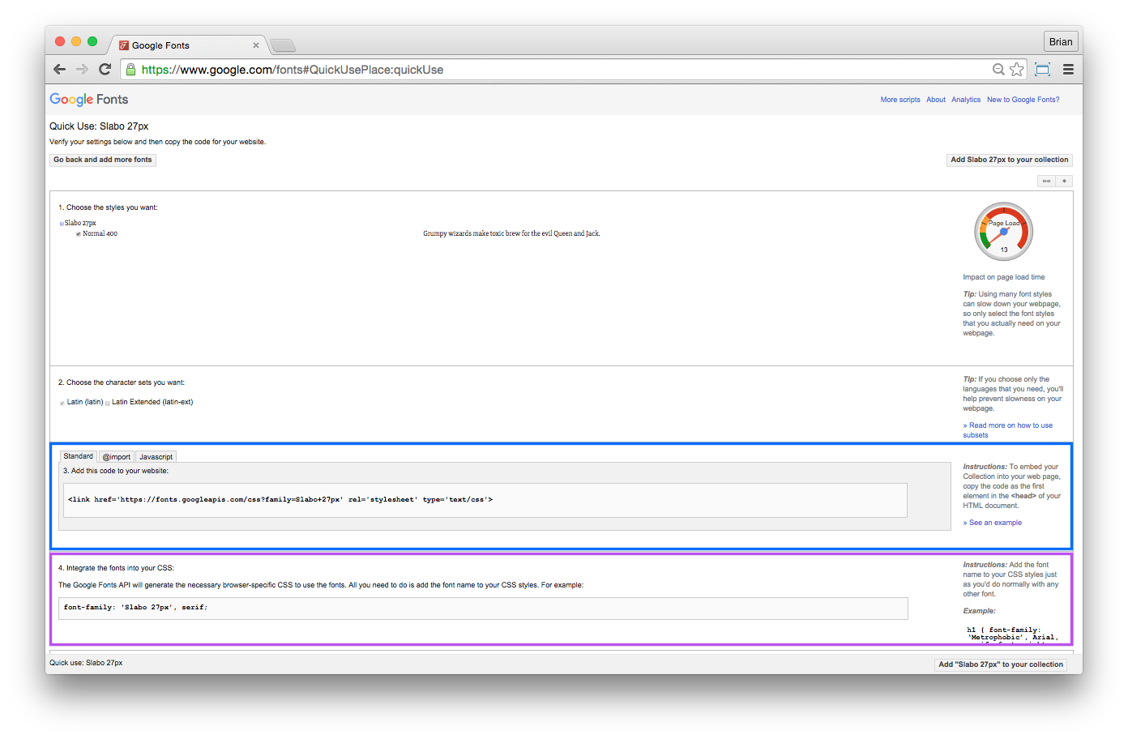

**Advanced:** If you’d like to go above and beyond, try adjusting your fonts even further by adjusting their letter-spacing, word-spacing, and line-height.

Be careful though, a little word and letter spacing goes a long way. keep it subtle for maximum readability!

## Step 4: Double-check!

Review the checklist below to make sure your project is ready to submit. By this unit, all of your content should be on the page, and your HTML should be complete. You can check your HTML for errors using The Validator. <https://validator.w3.org/>

1. I’ve validated my HTML and asked my mentor questions about any errors
2. All child elements are correctly nested inside their parent elements
3. I haven’t used too many different fonts on my page (2 or fewer is recommended)
4. I’ve overwritten all default font styles with my own css
5. My CSS in the correct order (fonts, element selectors, classes, id's)
6. I understand that I haven’t learned layout yet, but soon my page will start taking shape

**Want feedback on your project? Of course you do!**  
Book a 1:1 with your mentor.

## Step 5: Save, Sync, and Submit

After you’ve applied type treatment to your site with Google, save your page in the unit_4 subfolder of your local GitHub repository. Then, commit and sync your changes.

Finally, submit your project on Circuits by providing the link to your updated page using the URL for your online GitHub repository. Your URL should look something like this:

<http://your_repository_name.github.io/unit_4/index.html>

And you’re all set. Congrats on another great week!